**Creating an Analytical Dataset**

|  |  |
| --- | --- |
| Christopher Giler  Udacity Business Analyst Nanodegree | August 24, 2017  Project #2-1 |

## Step 1: Business and Data Understanding

*Provide an explanation of the key decisions that need to be made. (250 word limit)*

### Key Decisions:

*Answer these questions*

1. What decisions needs to be made?

Pawdacity currently has 13 stores open in the state of Wyoming, and is considering expanding by opening a 14th store within the state. A decision must be made to determine the best location to open the new store and whether or not the decision to expand will be profitable. Making these decisions requires compiling a dataset which can be used to project revenue for the new store for different cities in Wyoming

1. What data is needed to inform those decisions?

These decisions will be driven by a dataset containing the following information for each city in Wyoming in which a Pawdacity store is currently operating:

1. Total Pawdacity sales in 2010
2. City population based on 2010 Census data
3. Land area
4. Population density
5. Number of households with people under 18
6. Total number of families

In later steps, predictions will be made by considering data for other cities with potential to open a new store location:

1. Market/sales data for other pet stores in the city
2. Population and demographics for cities of interest

## Step 2: Building the Training Set

*Build your training set given the data provided to you. Your column sums of your dataset should match the sums in the table below.*

The dataset for current store locations is created by blending data from the following sources:

1. Monthly sales data for all Pawdacity stores in 2010
2. Population data from U.S. Census Bureau (2000, 2010, and estimated 2014)
3. Demographic data for each city and county in the state of Wyoming

The data is first aggregated by city, and then joined by city name. The resulting dataset contains 11 entries, with each entry representing a city in which Pawdacity currently operates. This dataset will be used as training data to build a predictive model for determining the new store location.

|  |  |  |
| --- | --- | --- |
| **Column** | **Sum** | **Average** |
| *Census Population* | *213,862* | *19,442.00* |
| *Total Pawdacity Sales* | *3,773,304* | *343,027.60* |
| *Households with Under 18* | *34,064* | *3,096.73* |
| *Land Area* | *33,071* | *3,006.49* |
| *Population Density* | *63* | *5.71* |
| *Total Families* | *62,653* | *5695.71* |

## Step 3: Dealing with Outliers

*Are there any cities that are outliers in the training set? Which outlier have you chosen to remove or impute? Because this dataset is a small data set (11 cities),* ***you should only remove or impute one outlier****. Please explain your reasoning.*

The following outliers were detected in the new dataset using IQR methods for each feature.

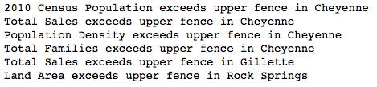

The first outlier is the city of **Cheyenne**, which exceeds the expected range for four features (2010 census population, population density, total families, and total sales). However, we would expect the state capital to be a more urban city compared to other cities within this dataset, so the high population density, total population, and total families all correlate with each other. A scatterplot of total sales against these three metrics also correlates with the linear relationship despite being an outlier in the data. This entry is left in to provide some additional robustness in the model for other more populated cities.

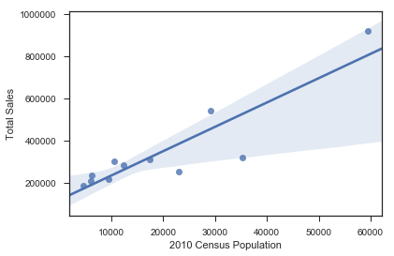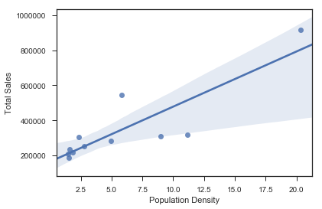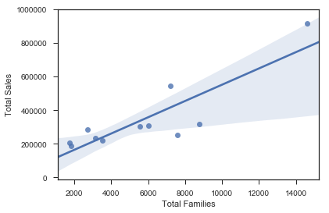

Total Sales vs. Population, Population Density, and Total Families; Cheyenne highlighted

**Rock Springs** is the second city which is considered an outlier based on land area. However, despite having a much higher land area compared to other cities in the dataset, it still correlates with a linear fit of the other data when looking at total sales against land area. Because it does not skew the data in this respect, this city will be left in the dataset as well.

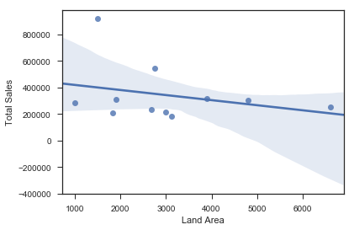

Total Sales vs. Land Area; Rock Springs highlighted

**Gillette** is the third and final city which was determined to be an outlier based on total sales, despite being within range for all other features. Because we observe that sales for this city is an outlier which cannot be explained by any other outliers found in the population or demographics metrics, leaving this entry in the dataset has potential to skew any models trained on this data. Therefore, this city will be removed from the data before building our statistical model.

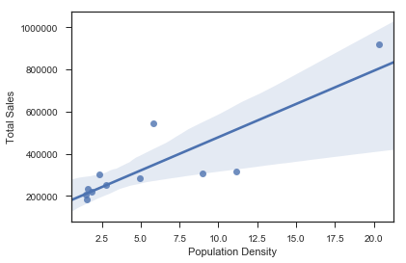

Total Sales vs. Population Density; Gillette highlighted

## Step 4: Build a Linear Regression Model

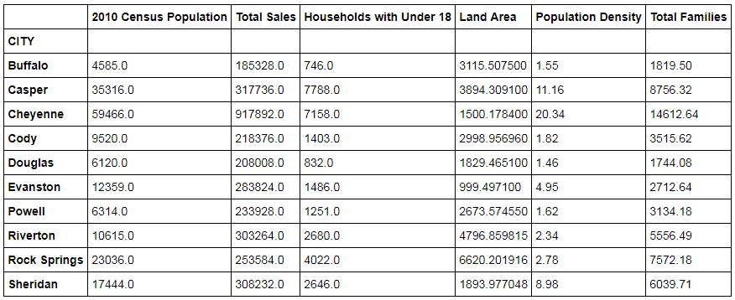

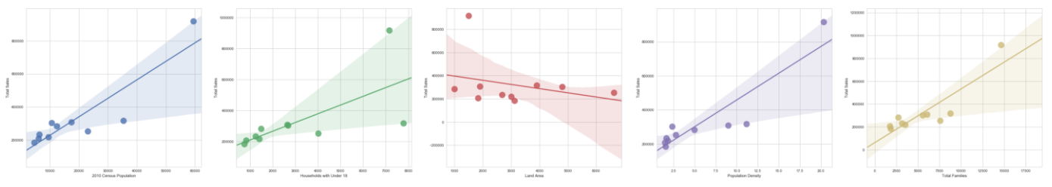

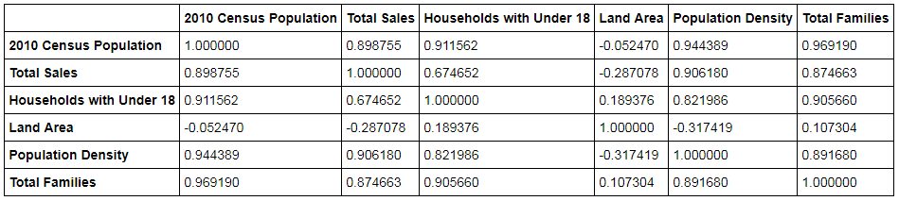

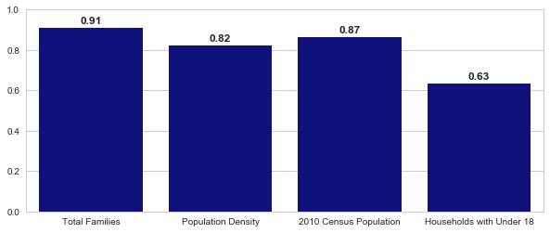

## Select features: Total Families & Land Area

Equation:



## Step 5: Perform the Analysis

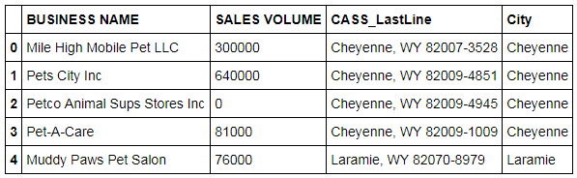

Aggregate by city and calculate sales volume sum

Note limitations:

* The new store should be located in a new city.
* The total sales for the entire competition in the new city should be less than $500,000
* The new city where you want to build your new store must have a population over 4,000 people (based on 2014 US Census)
* The predicted yearly sales must be over $200,000
* The city chosen has the highest predicted sales from the predicted set

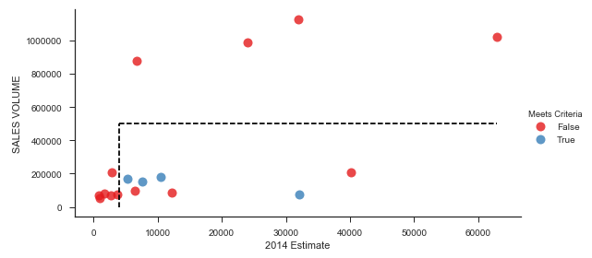

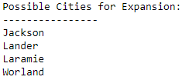

Results:

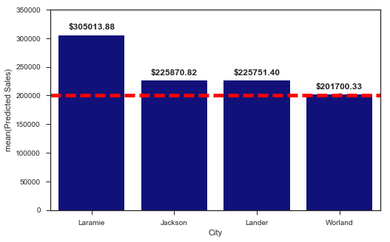

All are above criteria of $200,000

